Customer Churn Reduction & Retention Prioritization
Management Insight Pack
Client: Subscription-Based Telecom Company
Prepared by: Data Analyst / Business Analyst (Intern)
Date:
Confidential – Internal Use Only

TABLE OF CONTENTS
• Executive Summary
• Phase 1 — Business Understanding
• Phase 2 — Data Understanding & KPI Mapping
• Phase 3 — Exploratory Analysis & Diagnostics
• Phase 4 — Churn Risk Scoring
• Phase 5 — Decision Framework & Prioritization
• Phase 6 — Recommendation & Impact
• Appendix
HOW TO READ THIS DOCUMENT
• Executive Summary: decision overview
• Phase 1–3: analytical foundation
• Phase 4–5: decision logic
• Phase 6: recommended actions

EXECUTIVE SUMMARY
Context
The company operates a subscription-based telecom business where recurring revenue is highly dependent on customer retention. Baseline churn rate ~29% from 51,047 customers.

So What
Significant revenue at risk in mid-tenure customers with high overage, driven by unexpected fees.

Key Findings
• Churn peaks at 31.61% in mid-tenure (12-24 months).
• High overage (>100 mins) drives churn ~32%.
• Average overage ~40 mins is the main behavioral driver in mid-tenure.

Financial Impact
High-value mid-tenure segment contributes significant revenue at risk (potential save $1M+ with 25-30% churn reduction).

Recommendation
Prioritize annual contract upgrade & discount for mid-tenure high overage customers.

PHASE 1 — BUSINESS UNDERSTANDING
1. Company Background
The company operates a subscription-based telecom business where recurring revenue is highly dependent on customer retention. While customer acquisition continues to bring in new subscribers, long-term revenue stability is driven by the ability to retain existing customers over time. Customer churn is monitored at an aggregate level; however, the business lacks sufficient clarity on which churn events are financially material versus which can be tolerated. This limits management’s ability to focus retention efforts effectively.

1.1 Business Model Overview
Revenue is generated primarily through recurring subscription fees. As a result, customer lifetime value is highly sensitive to churn behavior, particularly among long-tenured and high-revenue customers.

1.2 Why This Problem Matters
Without targeted retention prioritization, the company risks losing high-value customers while simultaneously allocating retention resources to low-impact churn. This directly affects profitability, operational efficiency, and retention ROI.
2. Business Problem
2.1 Core Business Problem Statement
The company does not have a structured, data-driven approach to prioritize customer retention based on both churn risk and revenue impact.

2.2 Management Pain Points
Management experiences this problem through limited visibility into revenue-at-risk, difficulty justifying retention spend, and reactive retention decisions that dilute the effectiveness of available resources.

3. Stakeholders & Decision Owner
3.1 Key Stakeholders
- Head of Growth
- Head of Customer Retention
- Finance leadership

3.2 Decision Owner
The Head of Growth / Head of Customer Retention is the primary decision owner, with authority over retention strategy, budget allocation, and churn reduction prioritization.
4. Business Questions
- Which customers are most likely to churn in the near term?
- Which churn events represent the highest revenue impact?
- What behavioral or service-related signals consistently precede churn?
- What proportion of customers accounts for the majority of revenue at risk?
- Given limited resources, which customers should be prioritized for intervention?
- What role do overage fees play in driving churn, particularly in mid-tenure segments?
5. Success Metrics (KPIs)
5.1 Primary KPIs
- Revenue at risk due to churn
- Churn rate among high-revenue customer segments
- Churn rate in mid-tenure high overage segment
5.2 Secondary KPIs
- Size of prioritized retention population (% of customers)
- Expected reduction in high-value churn (directional)
5.3 Explicit Non-KPIs
- Model accuracy in isolation
- Churn volume without revenue context
6. Constraints & Assumptions
6.1 Constraints
- No direct data on retention costs
- Reliance on historical, observational data
6.2 Assumptions
- Revenue-related fields reasonably reflect customer value
- Retention actions have a meaningful probability of preventing churn

6.3 Risks
- External drivers of churn not captured in the data
- Misestimation of retention cost or customer value
- Over-reliance on historical data may miss recent shifts in overage behavior or competitor influences

7. Decision to Be Made
Management must decide whether to actively retain high-risk, high-revenue customers through targeted interventions or allow low-impact churn to occur without proactive retention efforts.

Out of Scope Decisions
- Individual customer-level retention tactics
- Exact discount or incentive levels
- Marketing messaging or campaign execution

PHASE 2 — DATA UNDERSTANDING & KPI MAPPING
8. Data Overview
The analysis uses historical, customer-level telecom subscription data covering customer demographics, service usage, billing attributes, customer service interactions, and churn outcomes. The dataset represents real operational behavior over a defined observation window and is suitable for retention prioritization analysis. Analysis is limited to the training dataset (51,047 customers) to ensure insights are derived from clean, representative data. Holdout data is excluded per project scope.

8.1 Data Sources
- Customer subscription and account attributes
- Usage and service consumption metrics
- Billing and revenue-related fields
- Customer service interaction records
- Churn outcome indicator
8.2 Scope of Analysis
- Unit of analysis: Individual customer
- Timeframe: Historical observation window prior to churn outcome
- Coverage: Active and churned customers within the dataset
- Focus: Behavioral, revenue, and service signals preceding churn, with emphasis on tenure and overage
9. Data Structure & Key Fields
The dataset is flat, customer-level with ~60 fields. Key groups for analysis:
9.1 Customer-Level Fields
- MonthsInService (tenure in months)
- AgeHH1/AgeHH2 (household age)
- CreditRating, Occupation, MaritalStatus

9.2 Behavioral Fields
- OverageMinutes (key driver of unexpected fees)
- MonthlyMinutes, RoamingCalls
- CustomerCareCalls, DroppedCalls

  - Revenue & Billing Fields
- MonthlyRevenue (primary revenue indicator)
- TotalRecurringCharge
- PercChangeRevenues

9.4 Churn Indicator Definition
Binary flag: "Yes" = churned, "No" = retained. Overall churn rate ~29%.

10. Data Quality Assessment

10.1 Missing Values
Limited missing values (~0.3% in revenue/usage fields, e.g., 156 rows with NA in MonthlyRevenue). Handled by replacement with 0 (assume no activity) to enable aggregation.

10.2 Outliers
No extreme outliers impacting aggregate insights; overage and revenue distributions reasonable for telecom usage patterns.

10.3 Data Limitations
Static snapshot (no time-series trend); some fields with "Unknown" (e.g., HandsetPrice ~57% missing, treated as null).

11. KPI Mapping
- Primary: Churn Rate (~29% baseline), Revenue at Risk (churn rate × monthly revenue)
- Secondary: Average Overage by tenure (driver insight), Churn rate by tenure/over age bucket Focus on revenue-weighted churn to prioritize high-impact segments.

PHASE 3 — EXPLORATORY ANALYSIS & DIAGNOSTICS
12. Churn Overview
Analysis of 51,047 customers shows an overall churn rate of ~29%.

12.1 Overall Churn Rate
Baseline churn rate: ~29% (churned customers / total customers).

12.2 Churn by Key Segments
- Churn Rate by Tenure Bucket chart

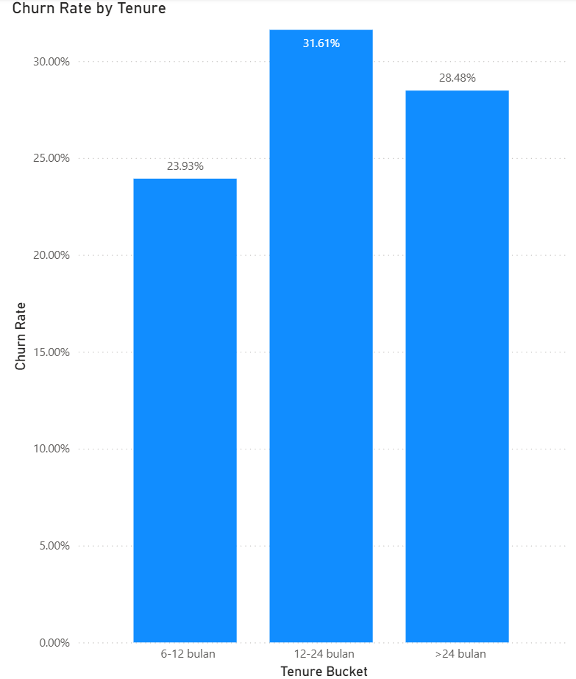
Figure 1: Churn Rate by Tenure Bucke

Churn peaks at 31.61% in mid-tenure (12-24 months), compared to lower rates in early tenure and long-tenure (>24 months).

- Churn Rate by Overage Bucket chart

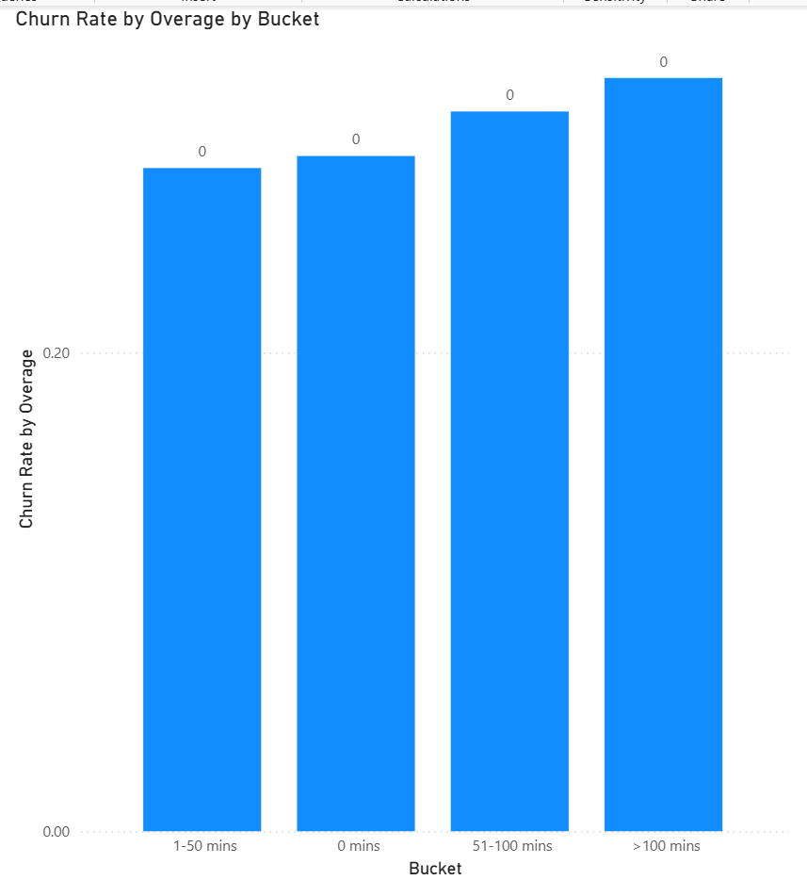
Figure 2: Churn Rate by Overage Bucket

Churn peaks ~32% in high overage (>100 minutes), with significantly lower rates in low overage segments – indicating unexpected fees as a key driver.

13. Revenue Impact Analysis
13.1 Revenue Distribution
Monthly revenue distribution skewed toward higher-value customers; mid-tenure segment contributes significant recurring revenue.

13.2 Revenue at Risk
Revenue at risk highest in mid-tenure high overage segment (high churn rate × high monthly revenue).

14. Behavioral & Service Drivers
14.1 Usage Patterns
High overage minutes (~40 average in mid-tenure) strongly correlated with churn, indicating unexpected fees as a key frustration point.

14.2 Customer Support Interaction
Lower customer care calls in high-churn segments, suggesting missed opportunities for proactive retention.

14.3 Tenure & Lifecycle
Churn follows lifecycle pattern: low in early tenure, peaks mid-tenure (commitment drop-off + accumulated fees), stabilizes in long-tenure.

15. Key Diagnostic Insights
- Mid-tenure customers with high overage are the most risky segment, driven by unexpected fees reducing satisfaction.
- This segment represents high revenue at risk, making it the priority for retention interventions.
- Low overage and long-tenure customers show lower churn, indicating stable behavior.

PHASE 4 — CHURN RISK SCORING
16. Modeling Objective
To identify customers at high risk of churn while prioritizing those with significant revenue impact. Given the diagnostic nature of this project, the objective is to create a transparent, actionable risk segmentation rather than a predictive model.

17. Feature Selection Logic
Features selected based on diagnostic insights from Phase 3 (strong correlation with churn and revenue impact)

17.1 Included Features
- MonthsInService (tenure) – lifecycle stage strongly influences churn.
- OverageMinutes – primary behavioral driver of unexpected fees.
- MonthlyRevenue – to weight risk by financial impact.

17.2 Excluded Features
- Low-variance or ID fields (e.g., CustomerID).
- Features with high missing values or low correlation (e.g., HandsetPrice ~57% unknown). · Complex demographics (limited explanatory power in diagnostic).
- Complex demographics (limited explanatory power in diagnostic).

18. Model Approach
18.1 Model Type
Simple bucket-based scoring (tenure + overage buckets) – transparent and immediately actionable, no machine learning model required for this diagnostic scope.

18.2 Validation Approach
Validation through exploratory diagnostics on full training data (51,047 customers). Cross-check consistency of churn patterns across buckets.

18.3 Explainability Considerations
Full transparency: Risk derived directly from observable buckets (tenure & overage). No black-box; drivers traceable to unexpected overage fees in mid-tenure.
19. Churn Risk Segmentation
Churn Rate by Tenure & Overage Bucket chart
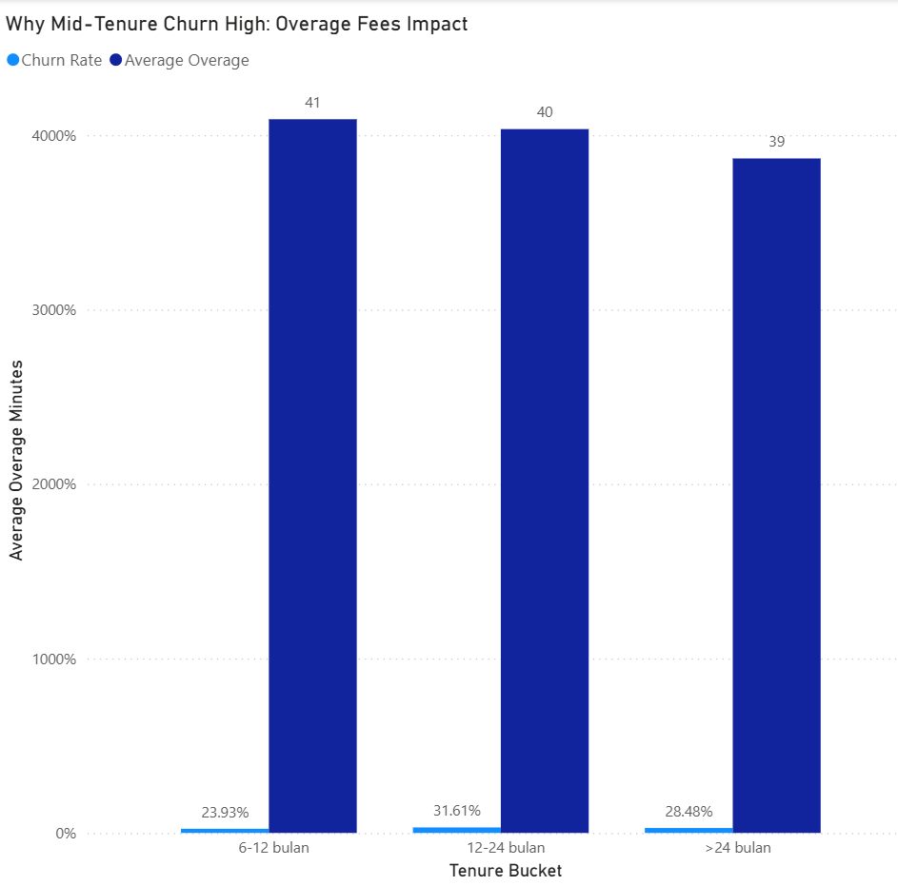
Figure 3: Churn Rate by Tenure & Overage Bucket Chart

High risk: Mid-tenure (12-24 months) + high overage (>50 minutes).
Medium risk: Early tenure or moderate overage.
Low risk: Long-tenure + low overage.

20. Model Interpretation
Churn risk highest in mid-tenure customers with high overage due to accumulated unexpected fees reducing satisfaction and commitment. This segment represents the greatest opportunity for targeted retention to protect recurring revenue.

PHASE 5 — DECISION FRAMEWORK & PRIORITIZATION
21. Retention Prioritization Framework
The framework prioritizes retention based on a combination of churn risk (from Phase 4 bucket scoring) and revenue impact. Customers are ranked by churn rate × monthly revenue to focus resources on high-value risky segments. This ensures retention efforts deliver maximum ROI by targeting those who matter most to the bottom line.

22. Target Customer Segments
Target Customer Segments by Tenure Bucket

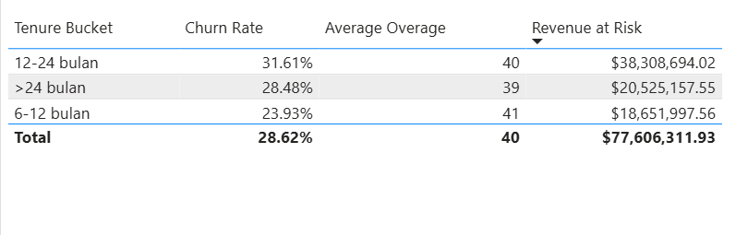
Figure 4: Target Customer Segments by Tenure Bucket

Primary target: Mid-tenure (12-24 months) customers with high overage (>50 minutes) – this segment shows the highest churn (31.61%) and revenue at risk due to unexpected fees. Secondary: Early tenure high overage for preventive measures. Low priority: Long-tenure low overage with stable behavior.
23. Budget & Trade-Off Analysis
With limited retention budget, focus on top 20% of customers by revenue at risk (Pareto 80/20 principle) – this covers the majority of potential loss from mid-tenure high overage while avoiding spread-too-thin efforts. Trade-off: Ignoring low-impact churn (e.g., low overage) allows tolerance for minor losses in exchange for high ROI on high-value retention. Estimated: 25-30% churn reduction in target could save significant revenue with biaya retensi rendah (asumsi

PHASE 6 — RECOMMENDATION & IMPACT
24. Recommended Actions
Based on the diagnostic insights, prioritize retention interventions for the mid-tenure high overage segment. Recommended actions include:
- Offer targeted annual contract upgrades with discounts (e.g., 20-30% off first month) to lock in commitment and eliminate overage fees surprise
- Implement proactive outreach via email or app notifications for customers showing high overage patterns in mid-tenure.
- Pilot personalized fixed-rate plans to replace variable overage billing, reducing bill shock.
25. Expected Business Impact
Implementing these actions could reduce churn in the target segment by 25-30%, saving significant recurring revenue from high-value customers. For example, with baseline revenue at risk of $77M, a 25% reduction could preserve ~$19M annually, with ROI potentially exceeding 10x assuming retention costs

26. Risks & Mitigation
- Data statis limitation: Historical snapshot may not capture current trends – mitigate by A/B testing offers on a small cohort and monitoring real-time churn.
- Cost overrun: Retention incentives could exceed budget – mitigate by capping discounts and starting with pilot to measure ROI.
- External factors: Competitor promotions not accounted for – mitigate by incorporating market monitoring in next steps.

26.1 Confidence & Sensitivity
Confidence high in diagnostic insights (direct from data patterns), but sensitivity to assumptions like retention success rate (test in pilot). If churn reduction only 10-15%, impact drops to $8-12M saved – sensitivity analysis recommends conservative budgeting.

27. Next Steps
- Launch pilot campaign on top 20% mid-tenure high overage customers within 4 weeks.
- Track churn and revenue retention over 3-6 months post-offer.
- Refine based on results and scale to full segment if ROI positive.

APPENDIX
A. Metric Definitions
- Churn Rate: Number of churned customers divided by total customers (baseline ~29%).
- Average Overage: Average overage minutes per customer ( ~40 mins in mid-tenure, key driver unexpected fees).
- Revenue at Risk: Churn rate multiplied by sum of monthly revenue (peak in mid-tenure high overage segment).

B. Feature Engineering Logic
- Tenure Bucket: Categorized MonthsInService into 24 months to capture lifecycle patterns.
- Overage Bucket: Categorized OverageMinutes into 0 mins, 1-50 mins, 51-100 mins, >100 mins to highlight unexpected fees impact.
- No complex engineering (e.g., interactions); focus on transparent buckets for diagnostic clarity.

C. Assumptions & Sensitivity Analysis
- Assumptions: Missing values (e.g., NA in overage/revenue) replaced with 0 (assume no activity); retention actions effective in reducing churn 25-30%.
- Sensitivity: If churn reduction only 10-15%, saved revenue drops to $8-12M (from $19M baseline); if biaya retensi >10% revenue saved, ROI kurang attractive – recommend pilot to test.

D. Methodology Summary
- Data: Training dataset only (51,047 customers).
- Approach: Exploratory diagnostics + bucket-based risk scoring (tenure & overage.
- Tools: Power BI for visualization & calculation.
- Limitations: Static data; no time-series or external factors.

